Bo Lin

**ECE 479/579 Digital Control Systems**

Homework Assignment #2

1. Write the Laplace transform of the following equations and then solve for x(t); the initial conditions are given to the right.

a) Dx + 8x = 0 x(0) = -2

b) D2x + 2.8Dx + 4x = 10 x(0) = 2, Dx(0) = 3

c) D2x + 4Dx + 3x = t x(0) = 0, Dx(0) = -2

d) D3x + 4D2x + 9Dx + 10x = sin 5t x(0) = -4, Dx(0) = 1, D2x(0) = 0

Because 

a)Sx-x(0)+8x=0

X(s)= -2/(s+8)

x(t)=-2*exp(-8*t)

b) X(s)= (3*s+17.6)/(s^2+2.8*s+4)

x(t)= 3*exp(-(7*t)/5)*(cos((51^(1/2)*t)/5) + (67*51^(1/2)*sin((51^(1/2)*t)/5))/153)

c) X(s)=(1/(s^2) – 2*s)/(s^2 + 4*s + 3)

x(t)= t/3 + (3*exp(-t))/2 - (55*exp(-3*t))/18 - 4/9

d) X(s)= (5*s + 5/(s^2 + 25) - 56)/(s^3 + 4*s^2 + 9*s + 10)

x(t)= (4*cos(5*t))/725 - (1909*exp(-2*t))/145 - (9*sin(5*t))/1450 + (329*exp(-t)*(cos(2*t) - (407*sin(2*t))/1316))/25

2. A satellite-tracking system is shown in the accompanying schematic diagram. The transfer function of the tracking receiver is

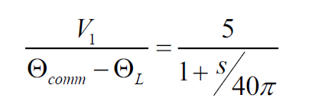

The following parameters apply:

Ka = gain of servo amplifer = 60

Kt = tachometer constant = 0.04V*s

KT = motor torque constant = 0.5N*m/A

Kb = motor back-emf constant = 0.75V*s

JL = antenna inertia = 2880 kg*m2

Jm = motor inertia = 7*10-3 kg*m2

1:N = gearbox stepdown ratio = 1:12000

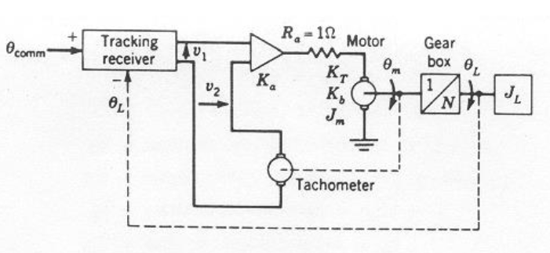

a) Draw a detailed block diagram showing all the variables.

b) Derive the transfer function L(s) / comm(s).

e=(V1-V2)*Ka

V2=Kt*ωm

e=ia*Ra+Kb*ωm

T=KT*ia

T=Jm*dωm/dt+Tgear

Tgear=JL*dωL/dt

ωL=N*ωm

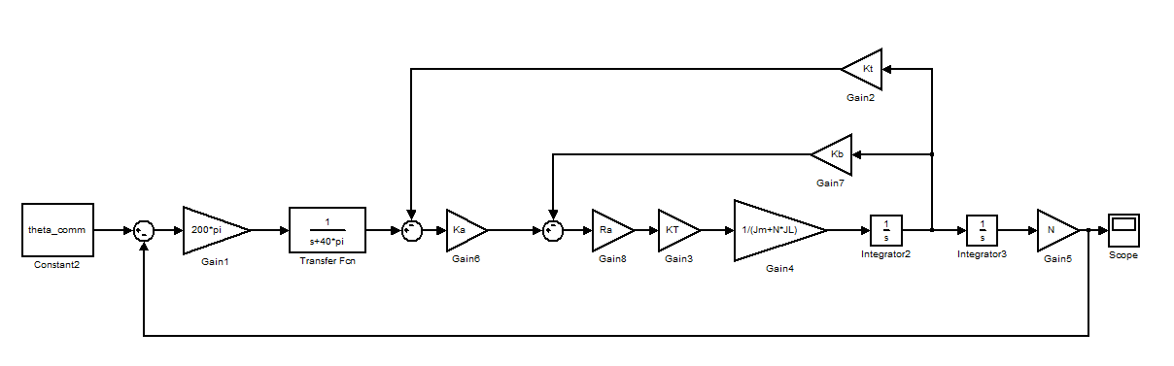

From inside loop to outside loop step by step:

$$G_{1}\left(s\right)=\frac{R_{a}K_{T}}{{S(J}_{m}+NJ_{L})}$$

$$G_{2}\left(s\right)=\frac{{K_{a}G}_{1}\left(s\right)}{1+K_{b}G_{1}\left(s\right)}$$

$$G_{3}\left(s\right)=\frac{200π}{S+40π}*\frac{G_{2}\left(s\right)}{1+K_{t}G_{2}\left(s\right)}*\frac{N}{S}$$

$$\frac{E(S)}{R(S)}=\frac{1}{1+GH}=\frac{R\left(S\right)-B(s)}{R(s)}$$

$$\frac{Θ_{L}}{Θ_{comm}}=\frac{B(s)}{R(s)}=\frac{GH}{1+GH}=\frac{G_{3}}{{1+G}_{3}}=$$

$$=\frac{K_{a}R_{a}K_{T}}{{(K}_{b}R_{a}K_{T}+R_{a}K_{T}{S(J}_{m}+NJ_{L})+K_{a}R_{a}{K_{T}}^{2})\left(S^{2}+40πS\right)+200NπK_{a}R_{a}K_{T}}$$